**ATAR CHEMISTRY – UNIT 3  
TASK 7 – Oxidation and Reduction Test**

**TOTAL MARKS:**

**/35**

**NAME: _______________________**

Answer all multiple choice answers on the slip of paper provided. Clearly write your short and extended answers in the space provided below. Where applicable show all working out and round final calculations to appropriate significant figures.

MULTIPLE CHOICE (6 marks)

1. Which one of the following pairs of statements is correct for both electrolysis cells and galvanic cells?



|  |  |
| --- | --- |
| **Electrolysis Cell** | **Galvanic Cell** |
| Both electrodes are always inert. | Both electrodes are always made of metal. |
| Electrical energy is converted to chemical energy. | The voltage of the cell is independent of the electrolyte concentration. |
| Chemical energy is converted to electrical energy. | The products are dependent on the half-cell components. |
| The products are dependent on the half-cell components. | Chemical energy is converted to electrical energy. |

1. Which of the following statements about oxidising and reducing agents is false?
2. Bromine water can oxidise chloride ions to chlorine.
3. Hydrogen peroxide solution is capable of spontaneous self oxidation - reduction.
4. Group I metals are good reducing agents.
5. Copper metal will react with a dilute silver nitrate solution.
6. Four metals Pb, *x,* *y* and *z*, were connected in pairs and the voltage was recorded.

The results obtained are set out in the table below.

|  |  |  |
| --- | --- | --- |
| ***Negative terminal*** | ***Positive terminal*** | ***Voltage (V)*** |
| Pb | *x* | 0.35 |
| *y* | Pb | 1.10 |
| *z* | Pb | 2.60 |

List the metals from **weakest** to the **strongest** reductant.

1. *z*, *y*, Pb, *x*
2. Pb, *x*, *y*, *z*
3. *x*, *y*, Pb, *z*
4. *x*, Pb, *y*, *z*
5. Using the standard reduction potential table, which statement is correct?
   * 1. Sodium is more likely to be oxidised than zinc.
     2. Magnesium is more likely to be reduced than copper.
     3. Iron will react in a solution of magnesium nitrate.
     4. There will be a reaction if magnesium is placed in sodium nitrate.

**Question 5 refers to the diagram and the equations below.**

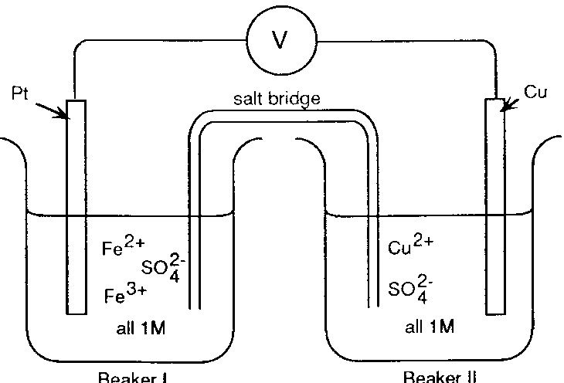

BEAKER I

BEAKER II

|  |
| --- |
| Fe3+ + e‾ Fe2+ E0 = 0.77 V  Cu2+ + 2e‾ Cu E0 = 0.34 V |

1. If the salt bridge contained KNO3 solution, the:
   1. K+ ions move from beaker I and are replaced by Cu2+ ions.
   2. NO3‾ ions migrate into beaker I and are replaced by SO42‾ ions from beaker II.
   3. K+ ions move into beaker II and NO3‾ ions move into beaker I.
   4. K+ ions move into beaker I and NO3‾ ions move into beaker II.
2. A student made the following observations:
3. clean metal A did not react with 1.0M B2+
4. clean metal B dissolved in 1.0M C2+ and crystals of C appeared
5. Clean metal C did not react with 1.0M A2+

The order of strength as a reducing agent is

1. A > B > C
2. A > C > B
3. B > C > A
4. B > A > C

SHORT ANSWER (13 marks)

1. Write any observations that would occur **after**:

(5 marks)

1. A strip of chromium metal is placed in a 1.00 molL-1 solution of cobalt(ii) nitrate.

______________________________________________________________________

______________________________________________________________________

1. Fluorine gas is bubbled into a solution of potassium chloride.

______________________________________________________________________

______________________________________________________________________

1. A piece of copper metal is placed in 2.00 molL-1 hydrochloric acid.

______________________________________________________________________

______________________________________________________________________

1. Mo3+ can be oxidized by potassium permanganate under acidic conditions to produce the molybdate ion (MoO42-). Manganese ions are also produce in the process.
2. Complete the table by writing balanced equations in the empty boxes.

(2 marks)

|  |  |
| --- | --- |
| Oxidation  Half-equation |  |
| Reduction Half-equation | MnO4-(aq) + 8H+(aq) + 5e- à Mn2+(aq) + 4H2O(l) |
| Overall Redox Reaction |  |

1. Use oxidation states to prove that the Mo3+ is being oxidized.

(1 mark)

1. Fluorine, F2, gas is the most reactive of all non-metals. Anhydrous liquid hydrogen fluoride, HF, can be electrolysed to produce fluorine and hydrogen gases. Potassium fluoride, KF, is dissolved in the liquid HF to increase electrical conductivity.

F2 is used to make a range of chemicals, including sulfur hexafluoride, SF6, and excellent insulator, and xenon difluoride, XeF2, a strong fluorination agent.

The diagram below shows an electrolytic cell used to prepare F2 gas.

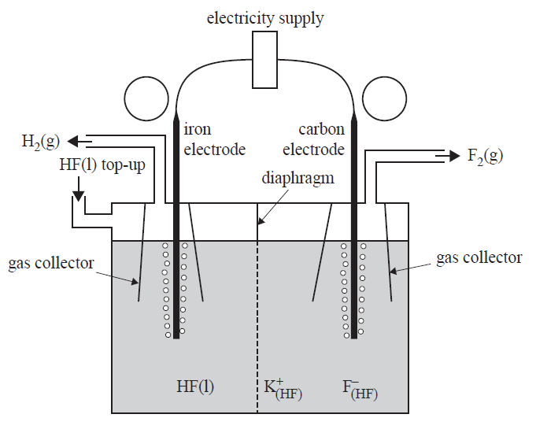

1. Label the polarities of each electrode in the circles provided on the diagram above.

(1 mark)

1. Write the equations for the half-reaction occurring at the anode.

(1 mark)

________________________________________________________________

1. Explain why the carbon electrode cannot be replaced with an iron electrode.

(3 marks)

________________________________________________________________

________________________________________________________________

________________________________________________________________

Extended Response (16 marks)

**Question 4(16 marks)**

The corrosion of iron and iron-containing structures is an ongoing and expensive problem. The subsequent rust that forms on an iron structure as a result of corrosion is flaky and weak. Rust not only changes the appearance of the iron, but decreases its strength. The consequences of this are wide ranging and diverse, and largely depend on the function of the iron structure.

The chemical processes occurring during the initial stage of iron corrosion can be represented by the half-equations below.

Cathode: O2(g) + 2 H2O(l) + 4 e- ® 4 OH-(aq)

Anode: Fe(s) ® Fe2+(aq) + 2 e-

(a) Prove, using oxidation numbers, that oxygen and water react at the cathodic site.  
(2 marks)

________________________________________________________________________

________________________________________________________________________

________________________________________________________________________

________________________________________________________________________

One common method which can prevent iron corrosion is the use of sacrificial anodes. These are often found in hot water tanks, where aluminium or zinc rods can be used to protect the iron tank.

In this situation, the cathode reaction remains the same, but the presence of a sacrificial anode prevents the iron from reacting.

(b) Explain why aluminium and zinc can be used as sacrificial anodes, but tin cannot.  
(3 marks)

________________________________________________________________________

________________________________________________________________________

________________________________________________________________________

________________________________________________________________________

________________________________________________________________________

________________________________________________________________________

(c) Write a balanced chemical equation for the redox reaction occurring when an aluminium sacrificial anode is connected to the hot water tank.(2 marks)

|  |
| --- |
|  |

A 545 g aluminium rod was connected to a hot water tank, to act as the sacrificial anode. It was known that, on average, 261 mL of oxygen gas would react each day.

(d) Calculate the number of years the hot water tank would be protected, before the aluminium rod would need replacing. Assume constant environmental conditions of 20.0 °C and 101.3 kPa. (5 marks)

________________________________________________________________________

________________________________________________________________________

________________________________________________________________________

________________________________________________________________________

________________________________________________________________________

________________________________________________________________________

________________________________________________________________________

________________________________________________________________________

________________________________________________________________________

________________________________________________________________________

________________________________________________________________________

________________________________________________________________________

(e) If a sacrificial zinc anode, of the same mass, had been used instead, would this provide longer lasting protection for the hot water tank? Support your answer with appropriate calculations.(4 marks)

________________________________________________________________________

________________________________________________________________________

________________________________________________________________________

________________________________________________________________________

________________________________________________________________________

________________________________________________________________________

________________________________________________________________________

________________________________________________________________________

________________________________________________________________________

________________________________________________________________________

**END OF TEST**